Name: G R Aakaash Slot: A
Reg No: 192412068 Course faculty: Sathish,K

Exp-7Analog Beamforming Analysis Using MATLAB

Objective-1: To analyze the beamforming gain achieved by varying the number of antenna elements in an analog beamforming system using MATLAB.

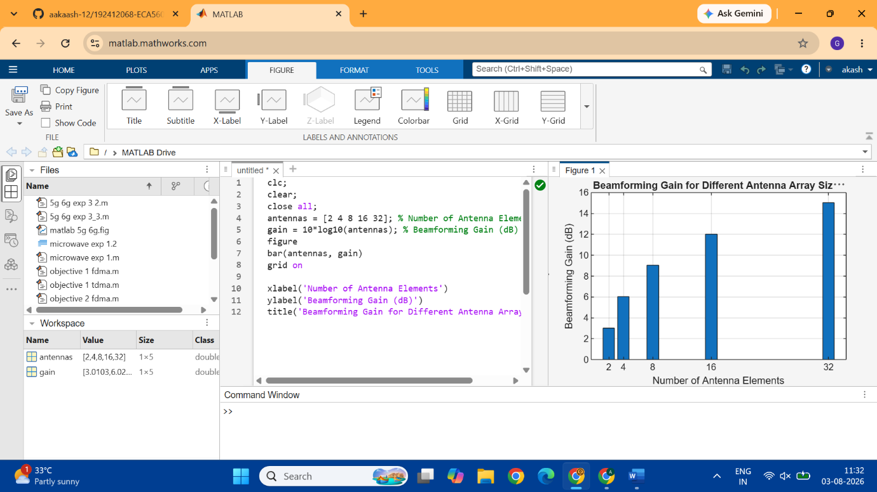
Code:
clc;
clear;
close all;
antennas = [2 4 8 16 32]; % Number of Antenna Elements
gain = 10*log10(antennas); % Beamforming Gain (dB)
figure
bar(antennas, gain)
grid on

xlabel('Number of Antenna Elements')
ylabel('Beamforming Gain (dB)')
title('Beamforming Gain for Different Antenna Array Sizes')
Objective-2: To compare the beam width of an antenna array for different beamforming configurations using MATLAB.
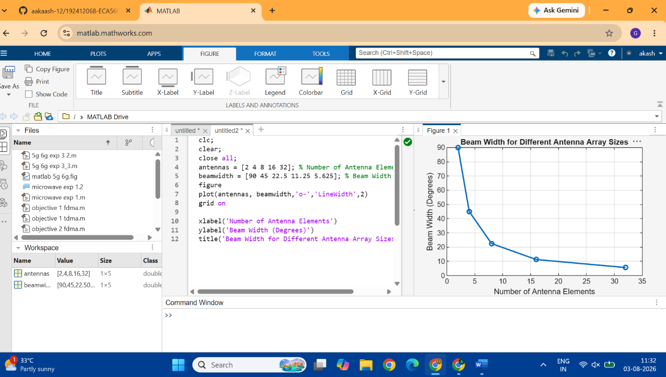
Code: clc;
clear;
close all;
antennas = [2 4 8 16 32]; % Number of Antenna Elements
beamwidth = [90 45 22.5 11.25 5.625]; % Beam Width (degrees)
figure
plot(antennas, beamwidth,'o-','LineWidth',2)
grid on

xlabel('Number of Antenna Elements')
ylabel('Beam Width (Degrees)')
title('Beam Width for Different Antenna Array Sizes')
Objective-3: To analyze the main lobe direction by steering the antenna array beam to different angles using MATLAB.
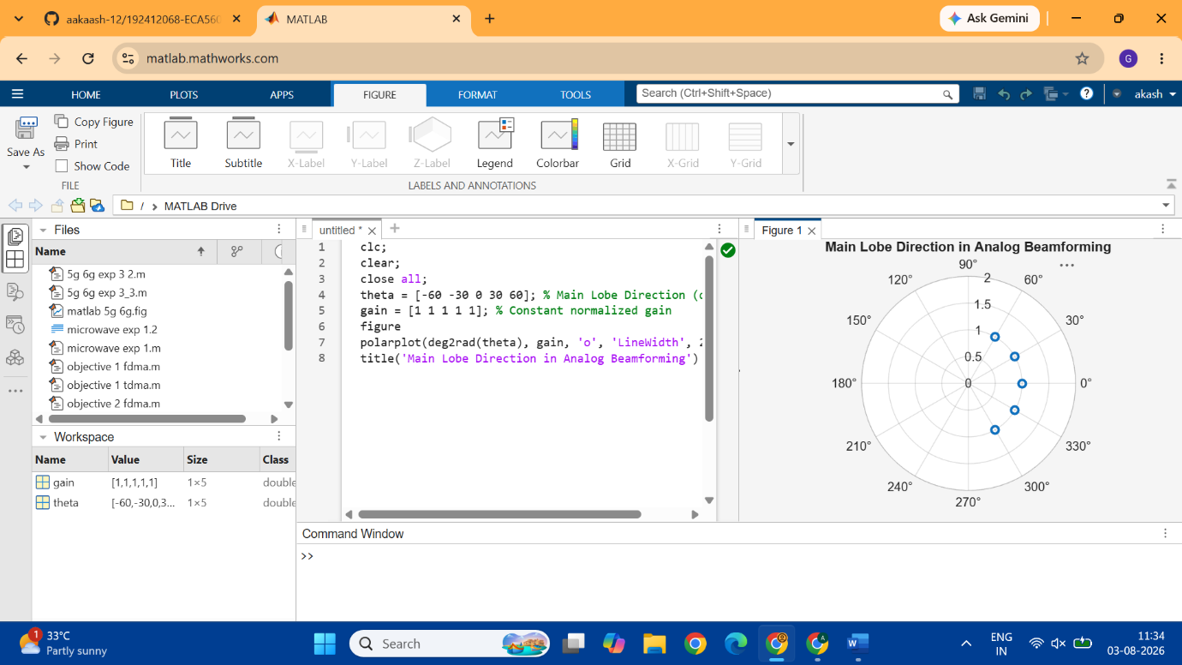
CODE: clc;
clear;
close all;
theta = [-60 -30 0 30 60]; % Main Lobe Direction (degrees)
gain = [1 1 1 1 1]; % Constant normalized gain
figure
polarplot(deg2rad(theta), gain, 'o', 'LineWidth', 2)
title('Main Lobe Direction in Analog Beamforming')

